**D. Cluster Analyses**

To identify possible latent classes of participants depending on scores on motivational risk factors, a latent profile analysis with the entire sample was conducted first. As all BIC values were very close to each other, additional cluster indices (e.g., Dunn index, silhouette index, DBCV) were calculated, which showed that the classes were hardly separable (i.e., they highly overlapped). Thus, we used a non-parametric clustering method (OPTICS) next; however, this approach resulted in a one-cluster solution, i.e., it was not possible to identify separable clusters. R scripts for these analyses are available in the osf project.

Because of the highly skewed distributions of the motivational risk factors (see Figure D1 for the entire sample), as well as considerable differences between the men and the women subsample on most of the variables, it was decided to categorise the variables and conduct latent class analyses separately for the men and women subsample.

**Figure D1**

*Distributions of All Motivational Risk Factors with the Entire Sample (N = 2764).*

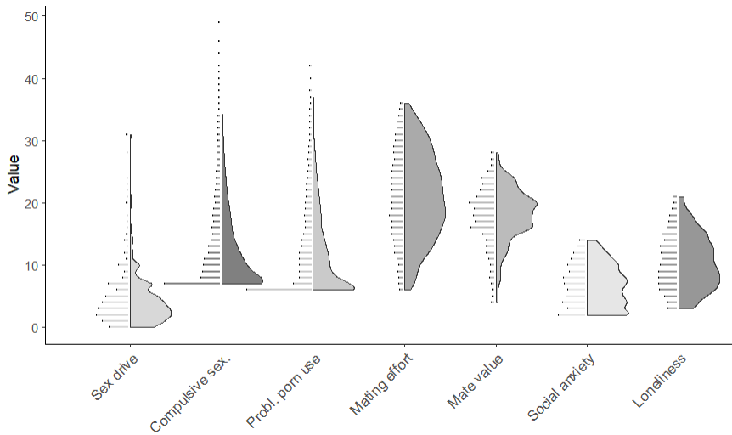

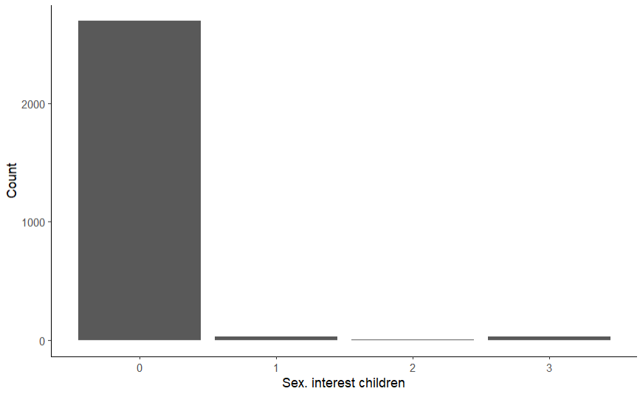

*Note.* Due to different scoring, the distribution for attraction to children is listed separately.